Supplements for online classes held on 18th July 2020
DR RAKESH MOHAN Dept of Zoology R N College, Hajipur E-mail – rzoornc@rediffmail.com
Integument its Basic Structure, Functions and its Derivatives with Comparative Account
Plate – 12
Plate – 13
Plate – 14
Plate – 15
Plate – 16
Plate – 17
Plate – 18
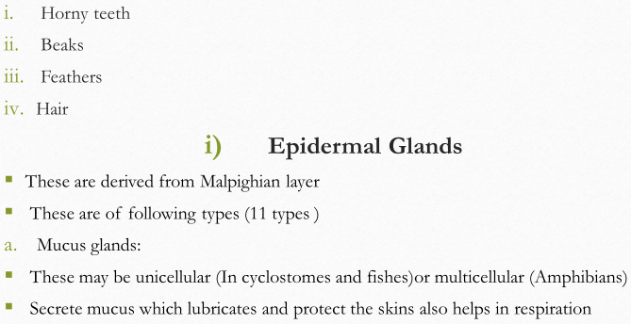
Plate – 19
Plate – 20
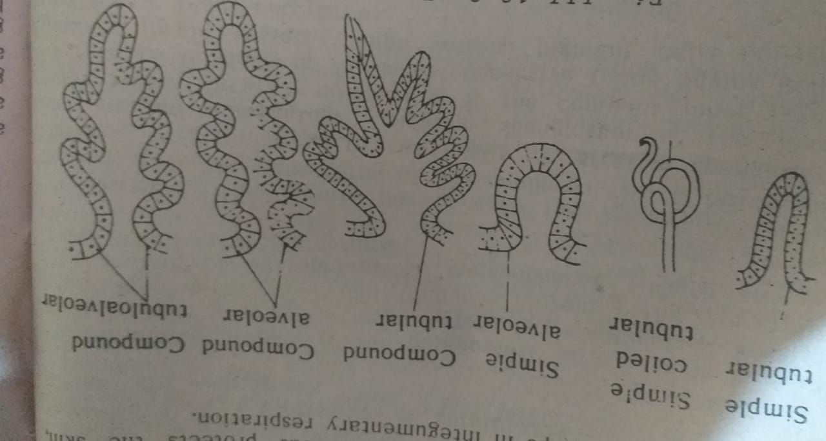
Plate – 21
